Eaton 2023-2024 Varsity Swim And Dive Schedule

DATE MEET Warmup & Meet Start SITE_____

9/16 NISD Sprint Meet WU-1:00pm MS-2:00pm NISD

11/11 Non-TISCA Invite WU-7:00am MS-8:30am KISD Nat

12/14 NISD JV Meet WU-4:00pm MS-5:00pm NISD

2/03 Region Non-Qualifier TBD Carroll Aquatics

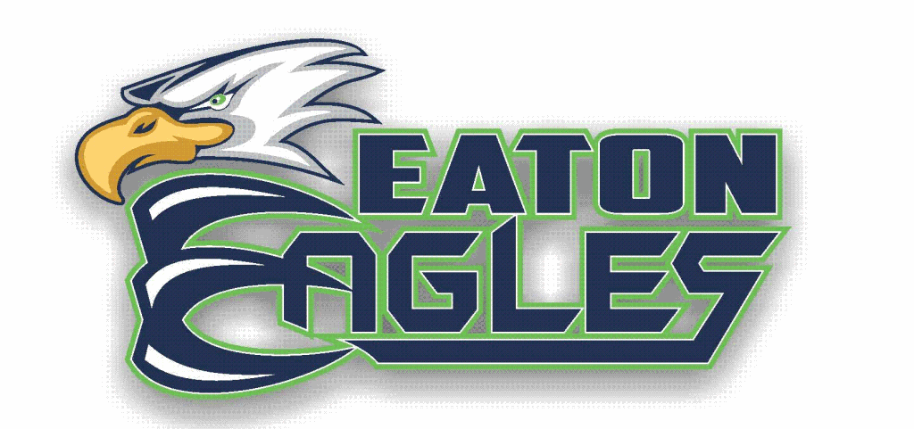

Competition Locations

NISD Aquatic Center: 1976 Texan Dr, Justin, TX 76247

KISD Natatorium: 1000 Bear Creek Pkwy, Keller, TX 76248

Carroll Aquatics Center: 1501 W Southlake Blvd, Southlake, TX 76092

